Hy there guys...
Haven't posted since last year, I demo traded and had pretty good results but didnt concentrate hard on forex but now I really want to study everything and just ''feel'' the market for TMS.
If Im going to study harder and become a good trader in lets say 1-2 years, can I make with TMS consistent profit every month (in the current or the future state of market/world) and also whats the average ROI for TMS per month ? Something like 8-9 % ?
THank you!

Hi iNs0mN1a,
This is a Frequently Asked Question FAQ.
Since you said you demo traded and have pretty good results, you need to continue practice on demo and analyse what your result would be like after 300 trades then 1000 trades.
Look at your own trade results for consistency and ask yourself if you have mastered this TMS system. What is your money management stategy and how good are you in managing your trading psychology.
Different traders trading the same system will have different end results. It will not help you decide by looking at another traders results.
If you ask TMS traders whether they cane make 8~9% per month, you will get a variety of answers. Some will tell you they can more than 20%. Will this help you in your decision to trade live?
It will be based on your trading ability to make the ROI you want. The market is dynamic, nobody knows what the market condition will be like and how this TMS need to be refine to changing market conditions.
Be mindful, trading a $10k account is very different from trading a $100k account. This has to do with the trader's mental strength in how he treats his money.
There are a lot of other considerations/factors one has to consider before he/she jumps into to trade for a living.
It is not that simple decision to make. Plenty of books out there to read and learn before taking the plunge.
Read Dr Alexander Elder " Trading for a Living" is where I suggest to start with.
regards,
Honesty is a v
Quoting khalidhassan

Would you please explain how to Use ATR(5) and ATR(10) to see the most recent volatility
Hi khalid,
That depends on which timframe you trade and you must consider the market volatility of that timeframe.
You can read up on ATR here:
http://forex-indicators.net/volatility-indicators/atr
regards,

Quoting Orbit
Thank You Emmanuel,
The volatility index is great idea and I will start to use it now on to determine the SL and would move it accordingly.
My problem is that I cant follow the market during the day as am at office 7 am to 5 pm which meanas I must use the TS. Any idea how best to use the TS for this method considering the above problem.
Many thanks,
You can consider to use a trade manager EA to manage your trades after you open.
Instead of TS, use Jumping Stop Loss 'JSL' instead.
There is a good multi purpose trade manager MPTM in the Commercial section:
http://www.forexfactory.com/showthread.php?t=89371
JSL is good when youi manager using R-miltiple.
For example, if your R is 50pips, you set your JSL to 50pips after Breakeven, the MPTM will move your protective stop every 50pips and protect your folating profits. You can also set the BE move to 50pips, this way the MPTM will move your trade to BE when market move +50pips above your Entry Price.
Try it, I used MPTM for 3 years and find it very useful.

“”

Hi All
I used this indicator on Feb 1st on GBPUSD 4 H chart
I have attached the chart showing the entery point with following cnfirmation:
- TDI lines crossed
- Red candle appearence in the chart
- Ist candle closed below the 5 MA yellow line
- Entery on the 2nd candle after above confirmation
This is my first entery on this method.
NB. I did not use the trial stop 20 points on the real account. In demo account I used it and SL got hit.
I suggest we discuss the SL best place. it seems the trial stop get hit fast with this method.
Pls free free to post your ideas, suggestion and recommendations to improve our trading using this method.
Orbit
Attached Image (click to enlarge)
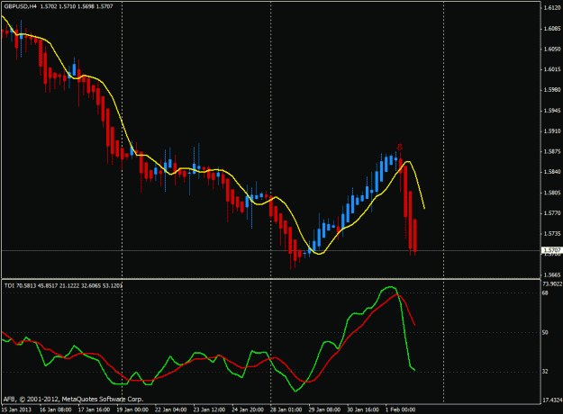

http://www.forexfactory.com/attachme...1&d=1359801626
When you are trading in the H4 timeframe, you must also consider the recent volatility in H4. Use ATR(5) and ATR(10) to see the most recent volatility. At the time of your entry, the ATR(5) and ATR(10) was betwen 48 pips and 50pips. Also the last swing high was about 51 pips above.
The best technical Initial SLwould be above this last swing high.
Trailing stop (TS) using 20pips is not a good idea as the price swings will take out your TS easily.
An effective method is to move your protective stops using the initial SL which is your risk "R". You move your stops to protect profit as the market move "R" pips from your entry point.
See chart example.
Attached Image (click to enlarge)
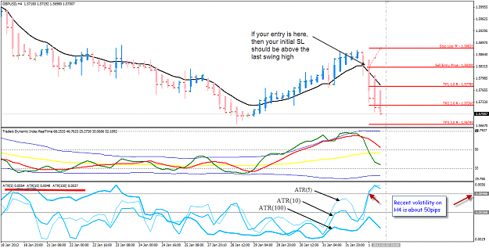
“””
Quoting Jackub
Emmanuel,
I have a newbie's question... 
On USD/CHF daily we have small red candle, after strong moove (Daily IB). The red one gonna be a retracemnt so in comming days we can expect bearish pressure. How deep this retracement can be..? This fibo pivot I've seen on old your charts can help to predict possible range of this kind a move??
Jacek
I see a historical support 0.9337, look for CONFLUENCE with other support and resistance if the retracement goes that deep.
otherwise, I look for shallow reatracement support near 0.9385

Quoting Babyboy
Hmm
Is there anyway to fastforward the time.
Watching the BEAR vs BULL is a hardest thing to do. Sometimes, gambling casino is easier. After couple of minutes, we know the results.
BUT 1000 ppl went into the casino, you will notice only 5% or less people walking out with a smiling face. The rest... the face sure blackish.
No wonder BigE had this method. Sleeping while the time past.... 
Asian dudes like me, always had an issued, why, cause this method started at 2pm, 6pm and 10pm. Always try to peek at the price action
moving...
it is just a waiting game, in between all the time let the bulls and bears have their fight while we wait for the outcome.
make that part of your lifestyle, like it or not if you want to be a successful trader and make a living out of it.
you only need to look at your chart once every 4-hours... after some time with experience, you will know when is the next 4-hour period when you will need to login and look at the charts again.
Honesty is a very expensive gift. You w

help how to filter such signals ?
Attached Image (click to enlarge)
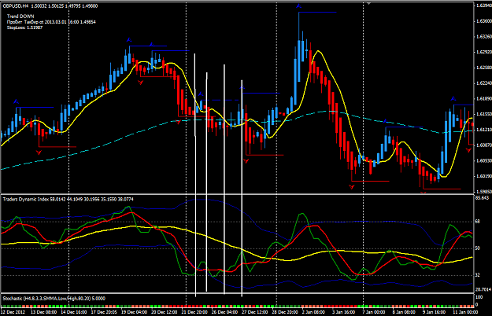

Answer
you chose the worst week in the calendar year to trade.
The SM started their holidays in that week and liquidity is low.
If I die die must trade, I follow the prev weeks trend and look for buy only, buy the dips.
where is the support for that week 52?
127% is the clue since we are on H4.
I love back-testing because highsight is perfect 20/20 vision.
But when we back-tests, we are programming our brains to look for repeated things.
Page 792
Dr Emmanuel, looking on daily AUDUSD, can we say,
red yesterday candle was continuation move upword after revers on a pin bar, then move lost momentum and start going down, and todays greeen candle is retracemet of downward move and propably price continue movig down...? 
Attached Image (click to enlarge)
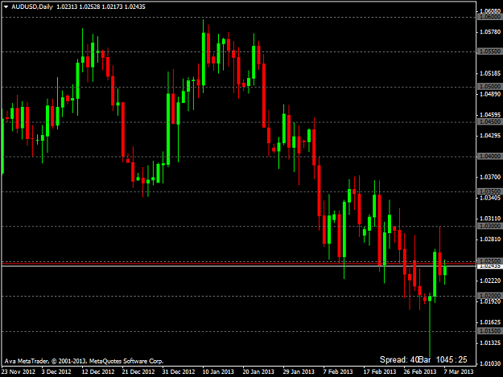

Answer
me not a doctor. I failed med school entrance and end up an engineer.
What is AU market type?
I see a wide ranging down flow. So I trade the weekly swings ups and swing downs.
I an a bear, so I wait upstream for the salmons to come to me. One D pin bar only tell me the salmons want to swim upstream.
When all the buyers exhaust themsleves, that my feeding time.

Quoting Rion
You are right but if there is a tendency turn, we will lose many points?
I am a swing trader and I trade higher probability trade setups.
I don't try to pick tops and bottoms. I don;t have the skills for that kind of trading.
When it does turn around, I will be right there waiting for that turn to be confirmed.
Enjoy the waiting!
Hi emmanual,
You are another very valuable contributor to this thread....so thank you very much for sharing your experience and knowledge.
As could be seen by my previous post addressed to snarlyjack it should be obvious that I am still struggling with using higher TF's as a filter or indicator of trend with the goal of increasing my probability of success.
So, I would appreciate it very much if you could elaborate a bit more about what you exactly mean with "......just take a look at the W candles, then the D candle. Do not trade against the W and D candles..." Does this means you look at the color or direction (bull or bear candle) of the last candle or is there more to it?
Thank you

Answer
For practice, do this little exercise:
Use EURUSD chart, we are trading H4, right? so we can't be scalpers, right?
Look at EURUSD weekly candles, previous weeks 2 huge Red candles.
Look at yesterday's Day candle, big Red candle,
so today, I will not want to trade against Red D and W candles, right?
Any greenie appears on H1 and H4 I look for SELL high!
That's my LOGIC.... that is BLUE hat thinking.
792
Quoting Rion
Probably strange question, how you manage to watch for so many currency pairs?
I only keep my eyes on five(5) currencies - AUD, EUR, GBP, JPY and USD.
After 5 years, it becomes easier with some good trading tools.
Your car' dashboard is great when it shows you some many things about your car engine working condition. When a light pops up when it should not, it alerts you to sometinhgs amiss.
So I have dashboard in my forex toolbox.
That make my life as a trader much easier and I have work life balance.

Quoting pundit78
Its also DBHC on EU daily, I like your idea to wait for retracement to atleast 38% or 50% to make and entry on H1, thanks.
yes, you are absolutely correct.
That's a Double Bar Low Higher Close (DBLHC) one of my favourites, and at 1.2970 historical support.
How can I missed that.
Thanks a lot. We don't trade alone, more eyers see more.
Trade Well All!
Quoting pundit78
Can you pls post some of your worst trade charts, so seniors can analyze and suggest what was wrong.
Hi,
here is my worst trade for this week 10.
I was a Bear waited upstream but caught no salmons.
Technically on chart, TDI show 4-6 positions, Stoch crossed down but in hindsight, there was a Support, But hindsight is 20/20 vision.
It is NZDUSD and it went no where after 2 days.
Closed - 20pips, close shop for this week.
Will sit out NFP.
Edit: Next week I am still Bear and will wait again upstream for those tired salmons swimming upstream. Have a look at W.
Attached Image (click to enlarge)

Quoting Raftron
I am looking for a set up on USD/CAD, H4 chart shows that cross of green and red is abuot to take place. 15M chart shows that price has cross the trendline, do you think that this is good enough for a confirmation even though the green has not cross the red line yet on H4?
I am think I should wait till this happens and then look for entry on 15M chart if the price bounces of the trendline.
What do you think?
well, this is what I thinl about USDCAD.
it has been trending UP in Jan and whole month of Feb.
To turn this around will take more than a few H4 candles.
I treat this week as consolidation before the next move.
If you are trading intraday, maybe 30pips is good profit for CT trade as position swing and buyers will exit and price back down a little. Others will just tighten their stops.
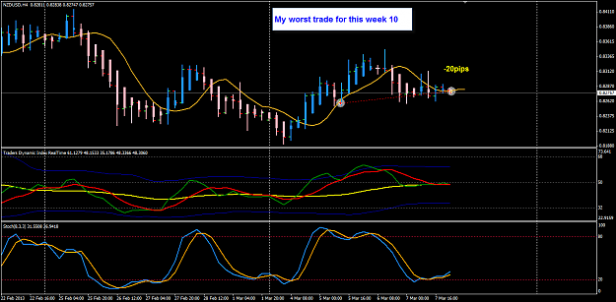

Quoting Winner1245
so you look at weekly candles everytime you place a trade on 4H??
If its up then buy the lows or down then sell the highs??
we are trend traders, and there is a process I follow everyday when I trade. I look at many things which covers these ten topics - PriceAction, Trend, Multi-TimeFrame, Momentum, Supportand Resistance, Continuation, Volatility, MarketStrength, Range, Timing.

“””

thanks again Guys, i really do appreciate the help,
i have read the two pdf,s of big E,s comments and im left with just one question regarding a conflict in his comments,
on one of the lists of comments he says enter the trade when green crosses red on that candle,
yet on the other set of comments he says when green crosses red and the next candle closes over the 5ema then enter !!
I don't worry about PA crossing the 5 ema. I totally depend on the TDI for my entry signals... Always entering when green crosses red and only on candle 1 or two depending what the TDI shows... otherwise I pass and look for another set up...
when pa crosses 5ema and closes that is the set up candle.........
can any of you clarify this ? which is it ?? looking back, i suppose both do work, but the latter gets better results,
think i just answered my question, i was trying to see when he made the comments - was one well after the other and in which order ? maybe he refined his strategy, but which way round ???
nelly

Hi Nelly,
Good point.
There is some discretion in Trading Made Simple. The discretion comes from screen time and back-testing and realtime live trading practice.
Like what Big E said few times in his posts, ... 'use your brain'. We must practice, practice,practice .... this is one of the ways to program our brains to see things which we want to look for in our charts. After many hours of practice, many of our trade decisions become intuitive. 4-hour is a very long time, and there we have time to wait and look for the technical setup conditions.
Attached is one EU chart example. I label two candles #1 and #2.
First exercise you do now is to answer that question, why is a trade entry after candle #1 close is a good entry. Give any 5 technical reasons.
Check the time you take to figure out the 5 reasons.
Regards,
Attached Image (click to enlarge)
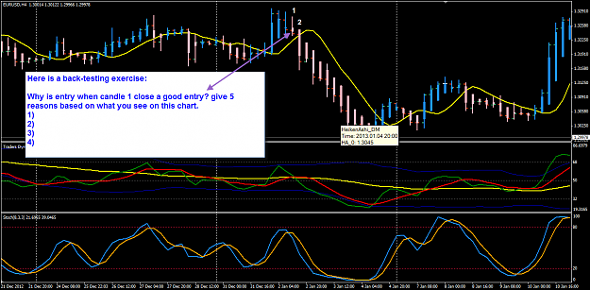
Page 798

Heeeeelp...
Pa is king,
Tdi is king......
Which one then ???
As a newbie just setting out, could any of you guys advise which bitz I need to learn to trade this system ?
I have read the whole post front to back and there is quite a lot of conflicting info,
Is it really necessary to learn and use fibs, chart patterns, and all the other bitz ??
Or is it just price action and the tdi ?
I can get my head round the tdi and I've made some pretty good trades, stayed out when candles are small and followed all other advise regarding the tdi,
But I'm Strougling to find what else I need to learn and where from regarding PA,
Many thanks for any help or advice ?.
Regards
Nelly

Hi Nelly,
If PA is king, and TDI is also king, ...then I say PA is the King of kings.
I suggest you pick up those pdf compilations of all eelfranz' posts and study them in depth. Pay more attention on how he explains about taking the TDI signal and reading the APB or HA candles. He did not ever once used those words 'Price Action' but his explanations were on reading the charts.
I hope this help you to find a way forward. When you come to a situation and not knowing what to do, please make a screenshot of your chart and be specific with some questions and I am sure many people here will help you.
Regards,

Quoting Nellycopter
On average how many pips are you guys making per day / week
with this method ?
Nelly
hi Nelly,
I am more interest in how many R's I make for every risk R I trade.
know your multiples and the expectancy of the system you trade with.
regards
Quoting tenmilewalk
hey guys. the slides below indicate the trades I have taken at the vertical line. (long or short dictated by TDI of course). Any advice appreciated.
It is good to practice.
But when I trade the H4 timeframe, I am are either pro-USD or anti-USD.
Short term intraday and scalping, I can ignore this rule.
AU is gap filling. ... after that gap is filled, then market will decide.
Keep practice, practice, practice.
Do Not Over-expose yourself. Also you cannot handle trade management with too many open trades unless you use an EA trade manager.

Quoting wizard99
Hey Emmanual,
Would you mind commenting on this...
The TDI has crossed down, however PA is still above the 10EMA. Do you see that occuring often, and in your experience do you wait strictly for the price pattern to change, or a close below the MA?...just curious as to how you approach this type of thing.
Cheers
W99
just think of it...
the TDI is based on the price of the last 13 price bars/candles.
this happen when price start to consolidates after the first TDI cross.
this happens when near 'supp/res' ... when buyers and sellers cannot decide.
When this happen, you kill that trade and wait again.
I love consoldiation because that will give us a potential breakout trade which is often explosive adn our initial SL will not be threatened and we can manage by moving trades to BE quicker and then sit back and relax, looom for other setups.
Honesty is a very expensive gift. You wont find it in cheap people.WBuffet

http://www.forexfactory.com/attachme...1&d=1363157719
Someone PM asked me what is that 'this is nice!" on my chart posted earlier
That is a Pop Gun after a Pin Bar. A good sign of increase demand and maybe that the downtrend has ended.
Attached Image (click to enlarge)
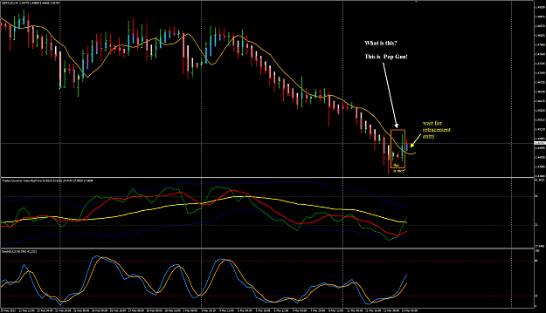

-  emmanuel7788
- Joined Nov 2008 | Status: Member | 13,514 Posts
Quoting sijeeva
thank emmanuel
here is my trade
http://i641.photobucket.com/albums/u...va/ferrufx.gif
http://www.forexfactory.com/[IMG...va/ferrufx.gif
good H1 trade. you pick on the continuation of the previous D close for entry.
thanks for sharing this.
there is a lesson for new traders to watch the D candle close .. and pick on the momentum of the D close and follow through to the next day..

Goodmorning everyone or in my case it's late at night,
Interesting triangle setting up on the gbp/usd.
Food for thought...trade well...
snarlyjack
Attached Image (click to enlarge)
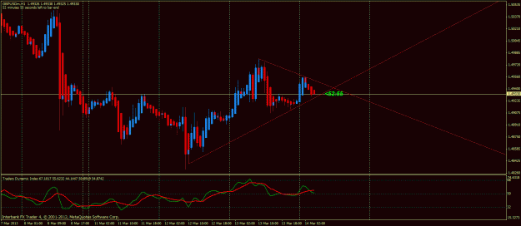

Goodmorning snarlyjack,
here is another view! ...25% UP 50% Sideway 25% Down ... my pick is 75% ?
Attached Image (click to enlarge)
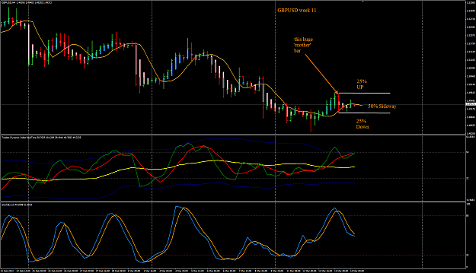

Quoting kk007
News bar.
well, that I believe in what moves the currency market too. 

That remained your belief since a few weeks ago when you first told me. I remembered but but did I believe you? 
How many of you believe what I told you about the Sydney first 2-hours range high-low? That was the 5R trade I was telling you about.
Attached Image (click to enlarge)
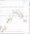
PG 1014
Quoting Kenshishi
Thank you Emmanuel, if i'm right, those 3 bars form a pop gun pattern.
Yes, learn to spot these kind of price consolidation on H4 and also D.
these are high probability setups and when it pops, it runs fast and furious.
if you are caught in the wrong pop direction, be ready with a Plan B and do to the turnaround.
It is very important when trading we have a Plan A and a Plan B and also a Plan C.
When the market prove us wrong,..Plan A fails, we activate Plan B.
We all trade our belief sabout the market. At some point in our trading, our belief no longer hold true. We must then do the TURNAROUND when our belief is no longer true. It is all in our minds. Trading require mental fitness. Train your minds.
Doing the turnaround is hard thing because it means we need to cut losses first. Nobody like to lose. That's is a common weakness in many of traders. But then as traders, we must believe that we must cut losses short and let proft run. That is the mantra everyday.
Trade Well folks!
I will be having my off-day today so no new trades unless some alarms goes off.

Quoting emmanuel7788
the sun is shining bright and the air is cool, so the Bulls (cows included) happily grazing :
http://www.forexfactory.com/attachme...1&d=1363242250
the bulls and cows still grazing, look for opportunity to join them in the fields....
Edit: GMT0915 ...sorry I know English may not be your first language for many people, when I say join the bulls and cows in the field, I did not mean to buy now. You need to do down the slope of the field to join the bulls and cows later. But you need to be a bear now ...got that?

Page 809

Quoting Britpip7
Any brave souls trading the gap?
http://www.forexfactory.com/attachme...1&d=1363558088
beware of dead cat bounce
Attached Image
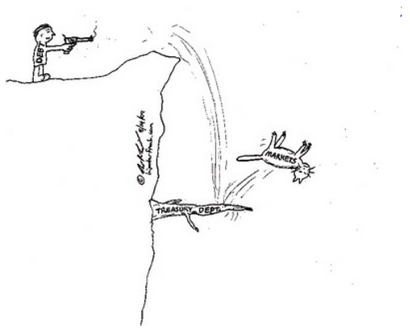

......
USD CHF from the H1 perspective
TDI looking for an up swing with mid zone approaching the 32 level
PA in a nice wedge so looking for the breakout.
Looking for a small retrace back to the 618 level which is just shy of the 200EMA.
Once this is hit, watch for continuation of the current day move south
Attached Image (click to enlarge)
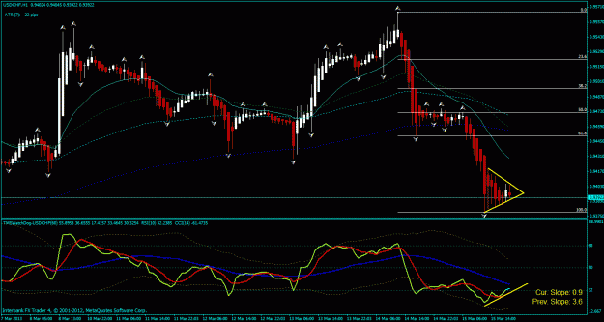
Nice H1 Mother Bar
It is going to be Sell but Sell High for next Week.
...............

Frequently Asked Question: TDI
For all who have access to MT4 on PC, simply use the TDI_RT indicator available.
However, for those who run MT4 in mobile platform like Andoid, or you run other trading platform which do not have the TDI indicator. You can simulate the TDI using two options shown in the attached pics.
It is not which method you use which will determine your trading performance and results.
It is how good your are at reading PA using the HA or APB.
If you see the TDI Green pointing 12-2 or 4-6 direction, it will be your skill in reading the PA that will help you decide whether that 12-2 and 4-6 setup is good to take a trade early before expecting a TDI cross. Sometimes the cross in lower TF end up a losing trade because of the higher TF PA tell a different story.
Always be careful whe market is ranging and volatility is low and there is no momentum in PA.
Back-test and learn this skill and master this in realtime live charts next week.
Trade Well.
Attached Images (click to enlarge)
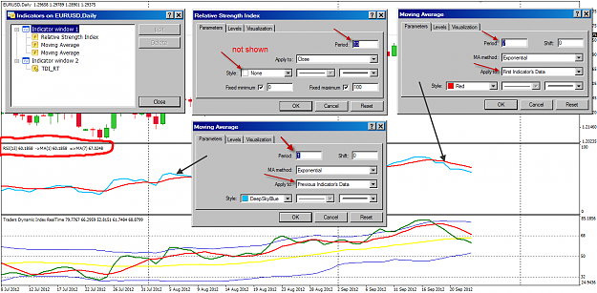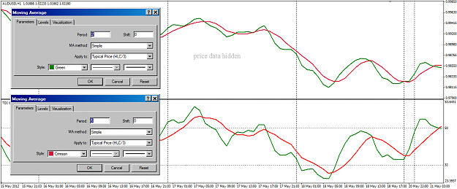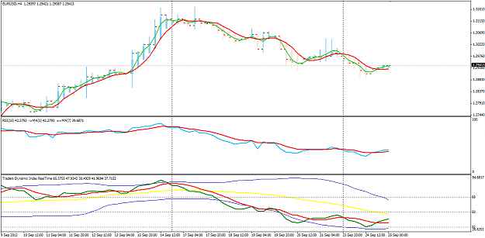

...............

Quoting adamjhdavis
Hi All,
Just a bit of research today....
I checked on nine charts today as the green goes over the red on the tdi chart. if you were to take the first four hours only and in effect scalp the market you could have had over 200 pips today.... what a system.
Thank you so very much big E, genius.
All the best to all.
Adam
(4 hour chart)
Exactly, you can trade with the Primary Trend on H4 like Big E do in H4 and we do the same here in this thread. .
Or you can scalp the Short Term trend in M15.
Or you can also Day trade the Intermediate Trend in H1.
You have to decide if you are a scalper, day trader or a swing trader .... or you can be a ALL-IN-ONE trader when you have developed the mental fitness to be a Trader.
Trade Well folks!
I love this pic below. have it in front of me all the time to remind me what I am trading at that very moment I see my charts.
Attached Image
